

ENGLISH

2024-2025 (Semester 5)

**Lydia Merle**

lydia.merle@institutoptique.fr

**THIS ENGLISH CLASS IS A TOOL BOX**

**TABLE OF CONTENT**

Handbook 3

Schedule 4

Assessment of the students 5

Tips for Oral Presentations 6-8

Tips for tenses 9-12

Topics for speaking and writing 13

**Individual Training (x4)**: 3 options or more:

-writing an essay (tips) 14-16

-BBC 6-minute English 17

-Ted talk 17

-any other suggestions?

-……………………………………………….

-……………………………………………….

-……………………………………………….

-……………………………………………….

English courses **HANDBOOK** 3rd year

**Semester 5:**

*Main objective: Become autonomous in your practice of the English language and get a good score for the English certification*

Linguaskill /TOEIC Reading, Listening

2 mock tests: Listening and Reading

Individual training to practice at your own pace

Watching the news and comment

Writing essays at home to get individual corrections

Vocabulary with Quizlet

Making short oral presentations (presentation 1)

Grammar explanations (tenses + according to the needs of the students)

Speaking activities (conversation, games)

**Semester 6:**

*Main objective: Get ready for next year and your professional life*

Making oral presentations (presentation 2 about the environment), taking into account the tips from presentation 1

Email writing

Solving problems on the phone

Writing your CV (document + “sell yourself” video (optional))

Writing a letter of application for (Master’s Degree/ Engineering school/ Internship)

Prepare for an interview

Prepare for the oral exams of IMT, Agro, GEI, etc…

Autonomous activities to practice at your own pace

Watching the news and comment

Writing essays at home to get individual corrections

Vocabulary with Quizlet

Grammar explanations (according to the needs of the students)

Speaking activities (conversation, games)

**SCHEDULE Licence 3 VCh 2024-2025 Semester 5**

|  |  |  |  |
| --- | --- | --- | --- |
|  | **DATE** | **CONTENT** | **FOR NEXT TIME** |
| 1 | Sept 3 | Expectations / Handbook (S5-S6) / Quizlet (professional Engl)/ presentation LSK&TOEIC / Websites/ Speaking about summer | Quizlet + be ready to talk about:  websites + LSK&TOEIC |
| 2 | Sept 10 | Quizlet / Oral Presentations tips (do’s and don’ts show) + organisation/LSK&TOEIC (sample Q°) / Speaking about topics | Quizlet + finish sample questions  Prepare Reading 1 |
| 3 | Sept 17 | Quizlet / Individual training explanation  + Tenses 1 (taught by the students) + Tenses 1 Q°1-10 p11  Reading 1 + Listening 1 / Speaking about topics | Quizlet / Individual training/  Tenses Level 1 Q°11-20 p11  Prepare Reading 2 |
| 4 | Sept 24 | Quizlet/ Individual training /  Tenses Level 1 Q°11-20 p11 / Tenses 2 /  Reading 2 + Listening 2/ Speaking about topics  Presentations: ………………….…………… / ……………………………….. | Quizlet / Individual training  Tenses Level 2 Q°1-10 p12  Prepare Reading 3 |
| 5 | Oct 1 | Quizlet/ Individual training  Tenses Level 2 Q°1-10 p12 / Reading 3 + Listening 3/  Speaking about topics  Presentations: ………………….…………… / ……………………………….. | Quizlet / Individual training  Tenses Level 2 Q°11-20 p12  Prepare Reading 4 |
| 6 | Oct 8 | Quizlet / Individual training  Tenses Level 2 Q°11-20 p12 /Reading 4 + Listening 4/ CNN-10  Speaking about topics  Presentations: ………………….…………… / ……………………………….. | Quizlet / Individual training  Prepare Reading 5 |
| 7 | Oct 15 | Quizlet / Individual training / Reading 5 + Listening 5/  Speaking about topics  Presentations: ………………….…………… / ……………………………….. | Prepare for the test (read ALL the tips and BRING your green document) |
| 8 | Oct 22 | **Mid-Term Test:**  **essay, tenses, Linguaskill/TOEIC (listening and reading)** | Enjoy your vacation! |
|  |  |  |  |
| 9 | Nov 5 | Quizlet/ Individual training  Correction of the test / Speaking about topics  Presentations: ………………….…………… / ……………………………….. | Quizlet / Individual training  Prepare Reading 6 |
| 10 | Nov 12 | Quizlet/ Individual training / Reading 6 + Listening 6  Speaking about topics  Presentations: ………………….…………… / ……………………………….. | Quizlet / Individual training  Prepare Reading 7 |
| 11 | Nov 19 | Quizlet/ Individual training / Reading 7 + Listening 7  Speaking about topics  Presentations: ………………….…………… / ……………………………….. | Get ready for the essay (read ALL the tips and BRING your green document) |
| 12 | Nov 26 | **Final Exam 1/2 : essay** | Get ready for Linguaskill + tenses |
| 13 | Dec 3 | **Final Exam 2/2 : tenses, Linguaskill/TOEIC** | Bring your Individual Training File |
| 14 | Dec 10 | Correction of the final exam + assessment of the course | **HAVE A NICE VACATION!** |

**Institut Villebon Georges Charpak**

**Assessment of the students L3**

**2024-2025 Semester 5**

**3 grades:**

**1-Mid-Term Test: 1/3**

-Essay writing /20

-Mock English certification and tenses /40

**2-Final Exam: 1/3**

-Essay writing /20

-Mock English certification and tenses /20

**3-Involvement of the student: 1/3**

Participation in class (+ Oral English, attendance and punctuality) /12

Individual training at home (x4) /10

**Will be AVAILABLE ON eCampus**

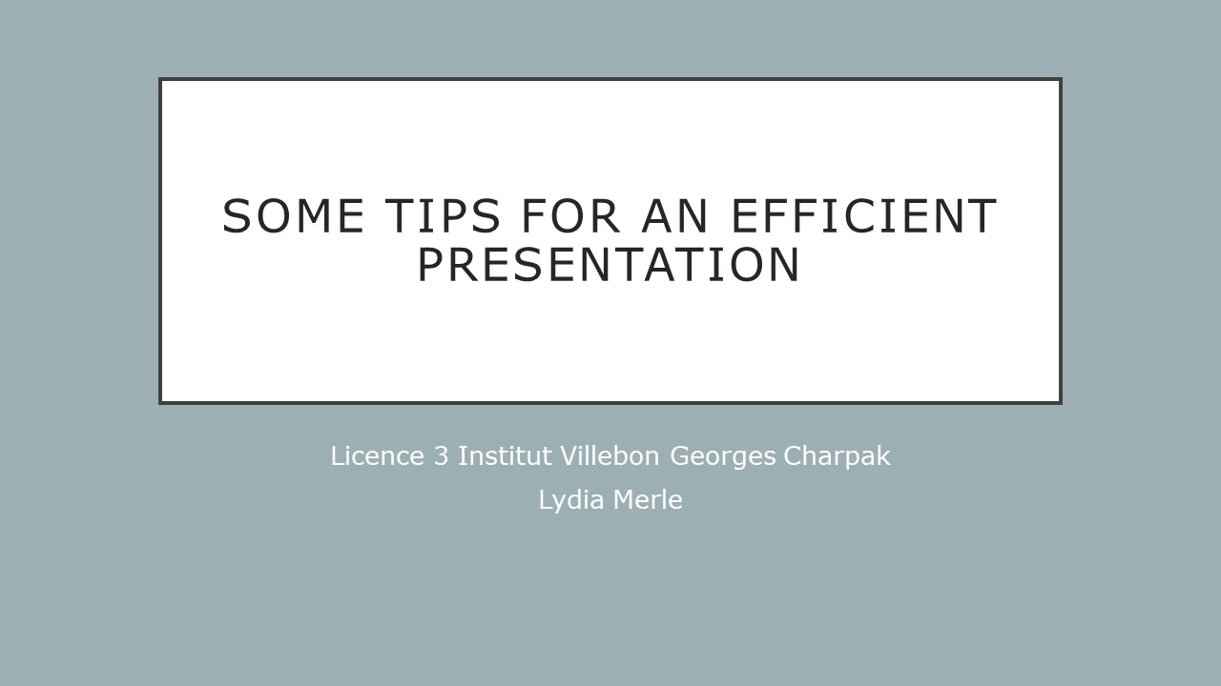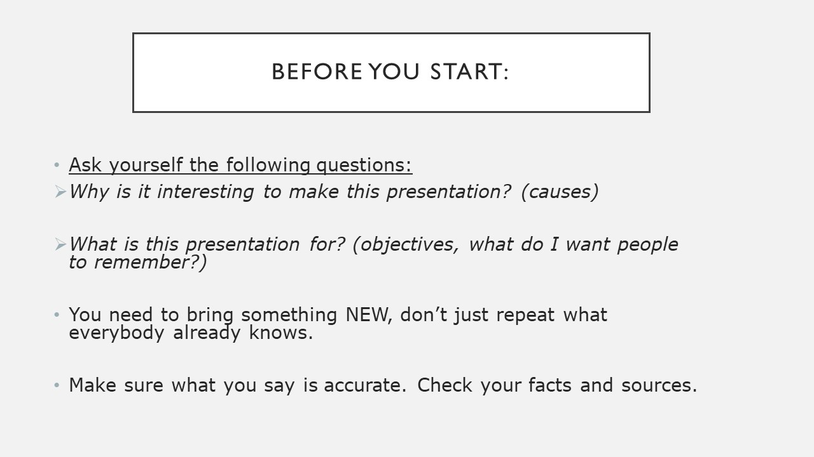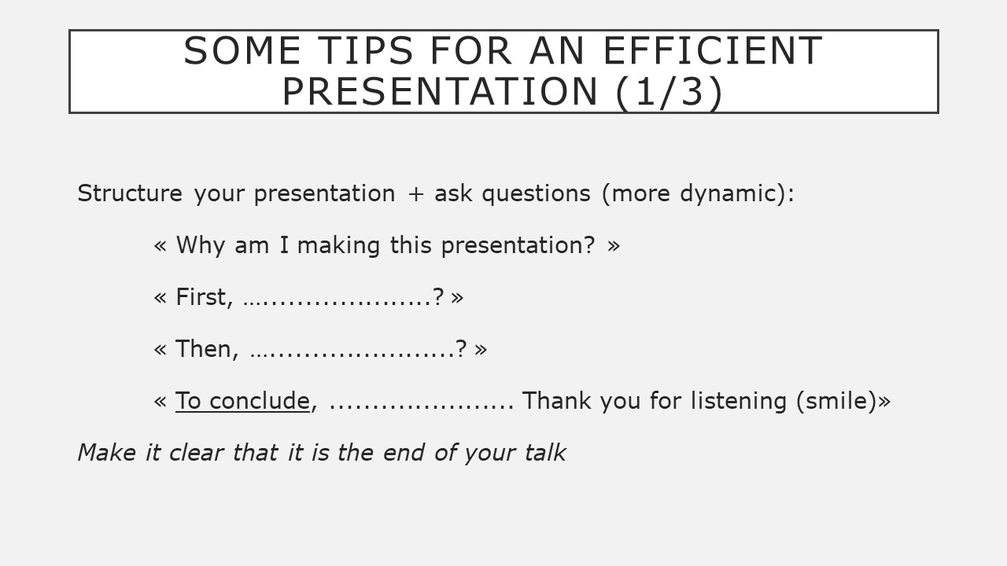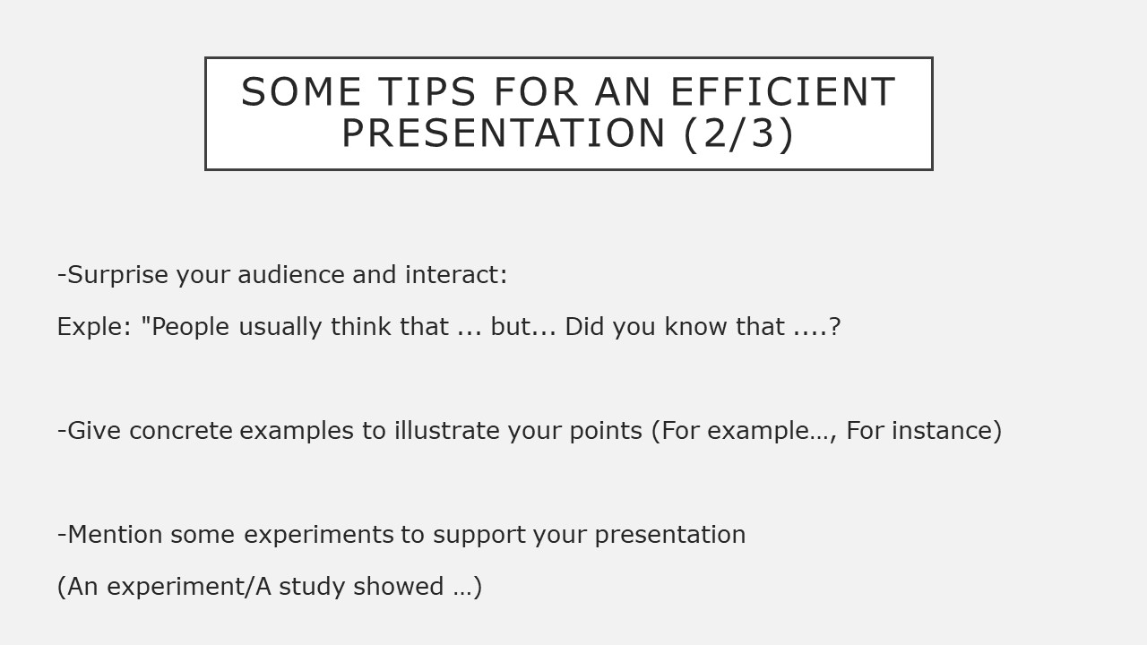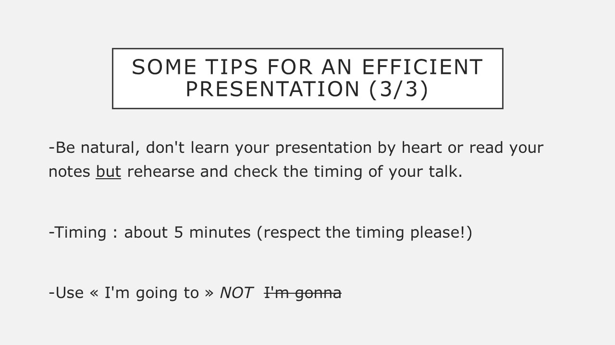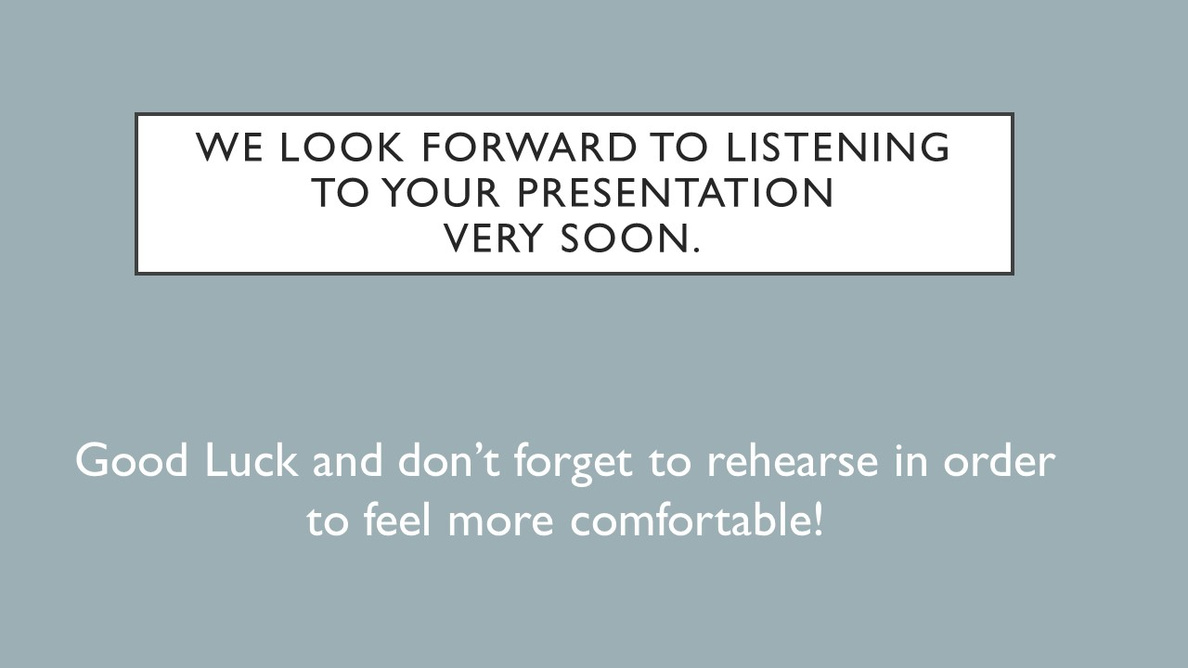

**LA CONJUGAISON DES VERBES EN ANGLAIS  Lydia Merle**

|  |  |  |  |  |
| --- | --- | --- | --- | --- |
|  | **FORMULE** | **AUXILIAIRE** | **EXPLICATIONS** | **EXEMPLES** |
| **1)**  **PRESENT SIMPLE** | S + verbe  « s » à la fin du verbe à la 3è personne du singulier | DO / DOES | -Généralités, caractéristique  -Vérité générale  -Habitude (everyday) | -Cats like milk.  -Water doesn’t boil_ at 30°C.  -Do you play tennis every day? |
| **2)**  **PRESENT BE-ING** | S + BE au présent + v-ing | AM / ARE / IS | -Situation spécifique  -Action en train de se dérouler sous nos yeux  -Verbes d’action (rarement verbes d’état) | -Look ! They are laughing!  -Are you coming with us?  -We are not going to NY this year. |
| **3)**  **PRESENT PERFECT SIMPLE** | S + HAVE / HAS + p passé  (au présent) | HAVE / HAS | -Utilisé pour parler de sa vie jusqu’à aujourd’hui, de son expérience.  -Pour faire un bilan ou décrire le résultat présent d’une action passée.  -Action qui commence dans le passé et qui continue au moment présent | -I have already been to Africa.  -Have you ever been to Las Vegas?  -I can’t read this, I have forgotten my glasses.  -I have just written these 3 letters.  -I have known him for ten years.  -I have not seen him for a long time. |
| **4)**  **PRESENT PERFECT**  **BE-ING** | S + Have/Has + been +v-ing | HAVE / HAS | -Permet de mettre l’accent sur l’activité et non sur le résultat.  -Permet d’insister sur la durée de l’action. | -I have been writing emails all morning!  -I have been waiting for 2 hours!  -How long have you been waiting? |
|  |  |  |  |  |
| **5)**  **PAST SIMPLE**  **(preterit)** | S + verbe-ed / v.irreg | DID | -Action ayant eu lieu dans le passé, souvent accompagnée d’un repère temporel passé.  (last, ago, in 1996…) | -I went to Africa in 1996. I worked there.  -Did you go to the party last night?  -I did not see my boss yesterday. |
| **6)**  **PAST BE-ING** | S + BE au preterit + v-ing | WAS / WERE | -Action qui était en cours à un moment du passé.  -Description dans le passé. | -We were eating lunch in the garden when the postman arrived. |
| **7)**  **PAST PERFECT**  **SIMPLE** | S + HAD (au passé) + ppassé | HAD | -permet de marquer une antériorité par rapport à une action passée exprimée par le prétérit.  -permet de rapporter des paroles qui étaient au prétérit ou au present perfect. | -Last week, I went to Japan, I had read many books about this country before.  -He said he had worked there. |
| **8)**  **PAST PERFECT**  **BE-ING** | S + HAD + been + v-ing | HAD | -permet de rapporter des paroles qui étaient au prétérit be-ing ou au present perfect be-ing. | -He said he had been waiting for 2 hours. |

**Write what you want to remember about the tenses in English :**

**FILL IN THE BLANKS  (level 1) + specify which line number of the table it refers to.**

1- He ………………………….know this book so I lent it to him. ( )

2-…………….. you ever been to the USA ? ( )

3-Just a second ! I ………. coming. ( )

4-I have been …………………. (stand) here for too long ! ( )

5-She had already ………………… (see) this movie when he decided to invite her. ( )

6-She …………………. want to come because she is scared. ( )

7-……….. they sleeping ? ( )

8-We ………. having tea in the garden when the rain started to fall. ( )

9-We ……….. often go on holiday. ( )

10-He said he was ………………… (come) at ten. ( )

11-He was born in 1932 and ………… (die) in 2007. ( )

12-What ……… he doing at 6 yesterday ? ( )

13-They ……….. been friends for 20 years now. ( )

14-It has …………………….. a long time since we last ………………… (see) you! ( )

15-How often …………… he call his best clients ? ( )

16-He is on holiday, so he …………. working today. ( )

17-………… you play tennis last weekend ? ( )

18-I have never …………….. (be) so happy ! ( )

19-I wouldn’t have come if I had ………………. (know) it was so boring. ( )

20-………. you understand better now ? ( )

**FILL IN THE BLANKS  (level 2) + specify which line number of the table it refers to.**

1-I ……………………………….. (play) football when I broke my leg. ( )

2-I …………………… (have) a bath 2 hours ago. ( )

3-Listen ! He ……………………… (talk) to her on the phone. ( )

4- I usually ………………....…. (go) to the swimming-pool once a week. ( )

I ……….…….. (go) to the swimming-pool once a week when I was a teenager.( )

I ………..……. (go) to the swimming-pool once a week for the last 6 months.( )

5-I …………………………… (meet) him in 2001 so I ………………………….. (know) him for several years now. ( )

6-Today, I woke up at 7:15, had breakfast at 7:30

and ……… (take) the bus at 7:45.( )

7-People usually ………………………(say) learning a foreign language is difficult. ( )

8-I ……………………………… (never see) the Statue of Liberty. ( )

9-He ……………………………………… (watch) TV all afternoon now! ( )

10-He said he …………………………………………. (already travel) to Europe. ( )

11-She ………………………… (live) in Paris for 10 years when she was a child and …………………………….(live) in New York for 4 years now. ( )

12-I ………………………. (buy) this shirt last summer. ( )

13- I ………………………… (know) him for 5 years when he died in 2007. ( )

14-Here you are ! Where ………………… you ……………… ? (be) ( )

15-Everybody …………………………………… (think) I am a hero. ( )

16-I …………just…………….. (break) my watch so I cannot tell you what time it is. ( )

17-I ………………….. (break) my watch yesterday and was really upset about it. ( )

18-I …………………….. already ………………………. (meet) someone famous. ( )

19-I …………………… (meet) someone famous last week-end. Guess who she was ! ( )

20-How long …………………….. you ……………………………(study) English ? ( )

**TOPICS FOR WRITING OR SPEAKING by Lydia Merle and her students**

|  |  |
| --- | --- |
| 1 | To what extend can art help improve society? |
| 2 | Do you think that sport should be mandatory in higher education? |
| 3 | If someone offers you a tattoo, how would you react? |
| 4 | What if a friend of yours has different political views? |
| 5 | Twitter and freedom of expression: where is the limit? |
| 6 | What are you most proud of? |
| 7 | What is one of your hobbies? |
| 8 | Is art a universal language? |
| 9 | What was your dream job when you were young? |
| 10 | What is your best memory with your friends? |
| 11 | Write or speak about a proverb you particularly like. |
| 12 | Story telling: Once upon a time… |
| 13 | What do you think about the English language influencing the French language a lot? |
| 14 | Should we change the French education system? |
| 15 | A visit you recommend (capital city, museum, tiny village, park, monument, country…)? |
| 16 | Do you think that videogames make people more violent? |
| 17 | Which word describes you the best and why? |
| 18 | What is your dream? |
| 19 | What is your favourite movie? Why? |
| 20 | Who is the person that makes you happy? |
| 21 | Diplomas vs Professional experience |
| 22 | What does “being free” mean to you? |
| 23 | What influenced your choice of studies? |
| 24 | Comment on the latest news. |
| 25 | Any topic connected to your field of studies or others. |

**FOR WRITING:**

Choose whichever topic you want.

Write your essay at home. It will be corrected but not graded so no need to use ChatGPT

Your essay should contain 10 to 220 words. Respect the word limit please!

PLEASE:

-**leave some space between the lines for the correction.**

-underline the linking words, the idiomatic expressions and the new expressions seen in class.

-avoid contractions like ~~don’t~~ > do not, ~~aren’t~~ > are not, ~~gonna~~ > going to, ~~wanna~~ > want to, etc.

-use CAPITAL letters for **N**ationalities, **C**ountries, **M**onths, **D**ays.

-avoid thinking about complete sentences in French, use only keywords (translation is a very difficult exercise).

**Get ready for the writing test:**

***(Don’t forget the green document)***

**MAKE SURE** you know how to**:**

* **structure** your essay
* **start** and **end** your essay with:

An introduction that:

-introduces the topic

-gives the outline of the essay with the proper expressions

(First, … )

A conclusion that:

-is introduced by the proper expression (In conclusion, …)

-recaps what has been mentioned in the essay

**MAKE SURE:**

* your **grammar** is correct
* your **sentence structures** are correct
* you know how to use the **linking words** in a relevant way.
* you know how to use some of the **expressions seen** **in class**
* your English is as authentic as possible using **idiomatic** expressions
* You respect the number of words (200-220)



**Is it possible to imagine a world without plastic?**

Plastic in our kitchen, plastic in our clothes, plastic in our hospitals. **Is it possible to imagine a world without plastic**? My essay will examine the question in three parts. **First**, I will analyse the possibility we have to replace plastic with other materials. **Then**, I will focus on the role played by governments. **Finally**, I will show the impact of individual actions on *such an* issue.

So, **to begin**, can we replace plastic**?** *I believe* there has been *significant* scientific progress because we *witness* the creation of biodegradable materials every day. For example, there are now waterproof bags *made out of* bamboo that are very convenient and useful.

**Secondly**, are governments around the world *taking actions***?** Many countries are now passing *eco-friendly* laws because fighting against the use of plastic has become a worldwide priority. For instance, New Zealand banned disposable plastic bags in 2019.

**Thirdly**, what about people’s behaviour**?** It also plays a *key* role because more and more people are starting to change their habits. For example, many individuals use bamboo reusable cups for their picnics.

**To conclude**, I would like to state that it is possible to imagine a world without plastic if scientists, governments and humans *get together* for *such a* *global* *achievement*.

(207 words)

**INDIVIDUAL TRAINING IDEA:**

|  |  |  |
| --- | --- | --- |
|  | **BBC 6-minute English** | **Ted Talks** |
| **1** | Je vais sur le site et je sélectionne un thème qui m’intéresse :  <https://www.bbc.co.uk/learningenglish/english/features/6-minute-english> | Je vais sur le site et je sélectionne un thème qui m’intéresse (duration 0-6 minutes) :  <https://www.ted.com/talks> |
| **2** | J’écoute la conversation et lis le script en même temps. | Je regarde la vidéo avec les sous-titres en anglais. |
| **3** | J’écoute une 2ème fois en faisant pause pour répéter chaque phrase  avec la bonne prononciation et la bonne intonation. | |
| **4** | Je sélectionne environ 10 mots que je ne comprends pas et que j’ai l’impression d’avoir déjà rencontrés. Je cherche leur traduction dans « wordreference » : https://www.wordreference.com/fr/ | |
| **5** | J’utilise chaque mot recherché dans une phrase simple. | |
| **6** | Je réécoute l’enregistrement sans regarder le script. | Je regarde à nouveau la vidéo sans les sous-titres. |
| **7** | Je mémorise les 10 mots nouveaux. | |
| **8** | Je rédige un petit texte en lien avec le thème :  résumé et/ou commentaire en utilisant le vocabulaire entendu. | |
| **9** | Je présente mon travail pour obtenir d’éventuelles corrections. | |
| **10** | Je prends en note les remarques pour pouvoir les appliquer sur mes futurs travaux. | |
| **11** | Je prévois une nouvelle séance de travail avec 6-minute English ou Ted Talks | |

**Présentation du travail:**

-Nom de l’étudiant + n° de la séance + thème choisi :

-10 mots avec leur traduction puis dans les phrases

-Petit texte

-Prochaine séance de travail prévue le …………………….. Lydia Merle sept 2022