# Supplementary material

Table S1. Technical specification of brick B and brick R (available from the manufacture, Wienerberger, Cheshire, UK).

|  |  |  |
| --- | --- | --- |
|  | Brick B | Brick R |
| Brick type | Facing brick  Extruded brick (wire cut) | Facing brick  Extruded brick (wire cut) |
| Size tolerances, mean and range | T2 / R2 | T2 / R1 |
| Durability EN 771-1 | F2 | F2 |
| Active soluble salts EN 771-1 | S2 | S2 |
| Compressive strength (N/mm²) EN 771-1 | >=20 | >=50 |
| Water absorption (%) EN 771-1 | <=6 | <=10 |
| Configuration | Perforated | Perforated |
| Dimensions (mm) | 215 x 102.5 x 65 | 215 x 102.5 x 65 |

(Note: Information of brick O is not available.)

Figure S1. Brick MFC assembly and experimental set-up; A) Type 1 brick B MFC with three anode chambers and three cathode chambers; B) Type 1 brick R MFC with three anode chambers and two cathode chambers; C) experimental set-up of Type 1 MFCs; D) Type 2 brick MFC with external anode and internal cathode; E) Type 2 brick MFC with external cathode and internal anode; F) experimental set-up of Type 2 MFCs

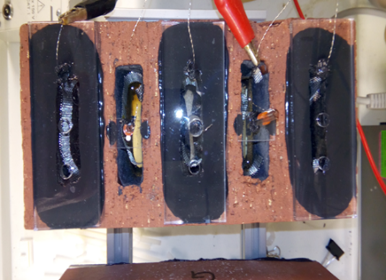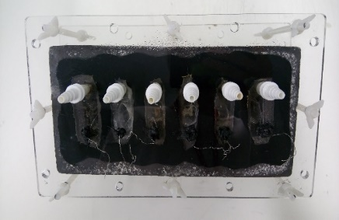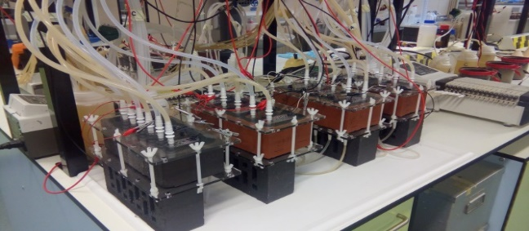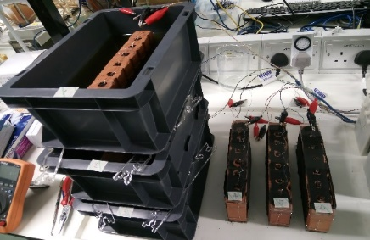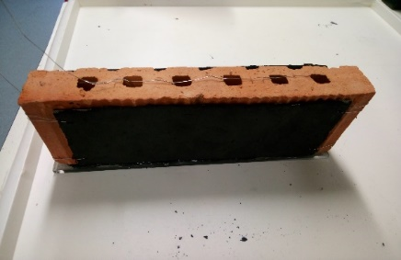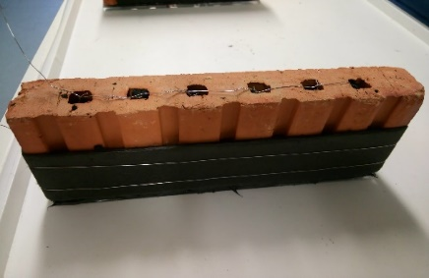

A

B

C

D

E

F

Figure S2. Scanning electron microscope (SEM) image of brick O (magnification of 4,000x)

D:\1. Jiseon\2017_09 LIAR (Living Architecture)\2018_03 3D printed box and Ugandan brick\SEM\U-brick x4000.tif

(Note: Quanta 650 FEG SEM (FEI, ThermoFisher Scienctific, Oregon, USA) was used for this analysis.)

Table S2. Energy-dispersive X-ray spectroscopy (EDX) analysis result of brick O

|  |  |  |  |  |  |  |  |  |  |  |  |  |  |
| --- | --- | --- | --- | --- | --- | --- | --- | --- | --- | --- | --- | --- | --- |
| Sample no. | Element (Wt% oxide) | | | | | | | | | | | | |
| C | Na | Mg | Al | Si | P | S | K | Ca | Ti | Fe | Total |
| 1 | 15.63 | 1.55 | 0.95 | 24.74 | 45.81 | 0.15 | 0.15 | 0.57 | 0.34 | 1.97 | 6.49 | 98.34 |
| 2 | 23.31 |  | 0.96 | 23.35 | 42.61 |  |  | 0.63 | 0.38 | 1.31 | 6.59 | 99.15 |

(Note: Quanta 650 FEG (FEI, ThermoFisher Scienctific, Oregon, USA) was used for this analysis.)