**USE FIJI TO DEFINE ROI AND OBTAIN F VALUES**

**Start**

Open your tiff file with FIJI

Scroll to watch the timeseries => Select the frames you want to work with

Create a new stack with only those frames (image -> duplicate -> define title (indicate the range and the original file) and range).

Reorientate your image if necessary such that the posterior part of the VNC = bottom of the image (image -> transform -> rotate)

Save it

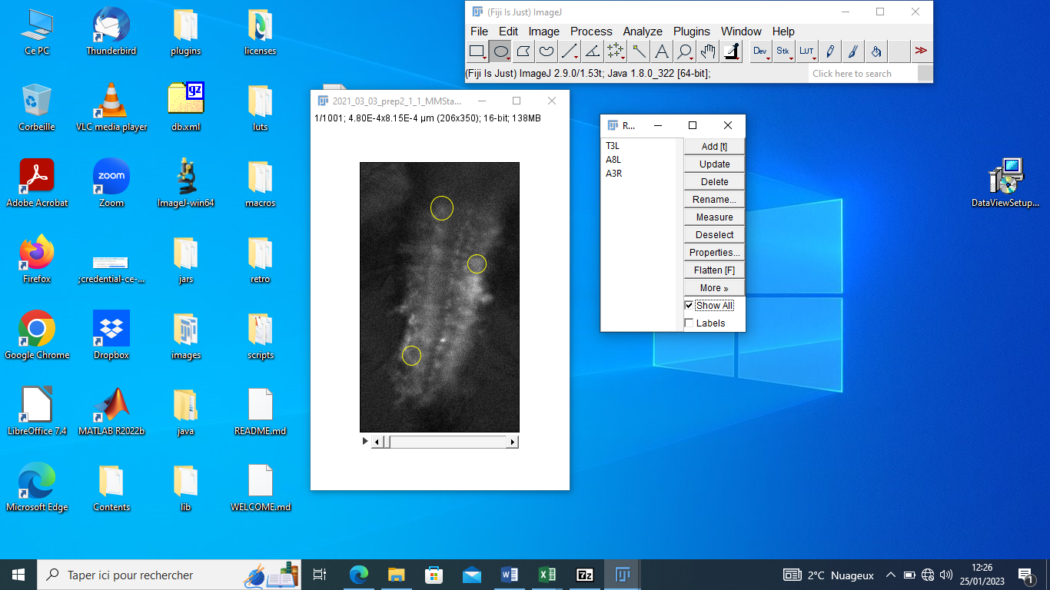

**Define regions of interest (ROI)**

Open the ROI manager (Analyze -> Tools -> ROI Manager)

Draw circles to define an ROI, then add it to the manager and rename it following the example in the report – save the ROIs

Once you are done with all ROIs, show them all (« Show All »), make a printscreen and paste it on a .doc file which you will save

**Obtain the fluorescence value**

Select the 4 ROIs which you want to measure -> More… -> Multi-Measure -> yes

You can save this file as a csv, or select all and paste it in a xls file (the 2nd option is easier)

On Excel, compute the deltaF/F0 for your 4 ROIs (use the mean fluo) and make a plot.

Reminder : delta F/F0 = (Ft-F0)/F0