**step 1**

Create the rules based on the theme. Consider the following questions:

1. What is the objective of the game?   
Get somewhere, rescue somebody, escape from somewhere, find something, collect bonus points, be the first one to get to a point, etc

2. Who are the players? How many players can play? Do players follow the same path?

3. What are the start and end points? Where are the players at the beginning of the game and what is their goal and the purpose of the journey?

4. What obstacles are there for the players to set them back, quit, stop, or change the rout?

5. What advantages can the players get to move forward? Are there any shortcuts? Are there any perks or "lucky" steps?

**step 3**

What layout will work better for your game?

  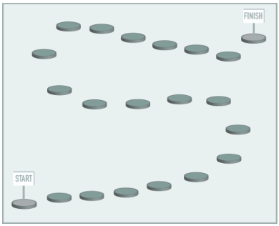 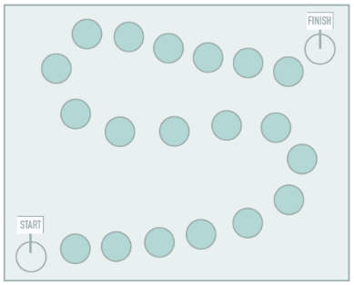 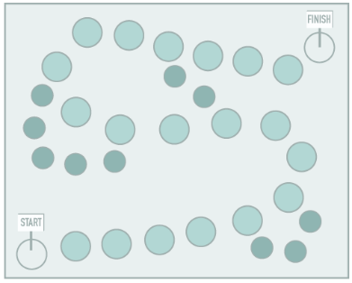

#### step 3

Design the board. Use full size drawing paper.

 1. Start with the background / setting. Include possible "obstacles" and "advantage" spots.

#### 

2. Add start and end spots.

#### 

3. Add obstacles that would slow down the players.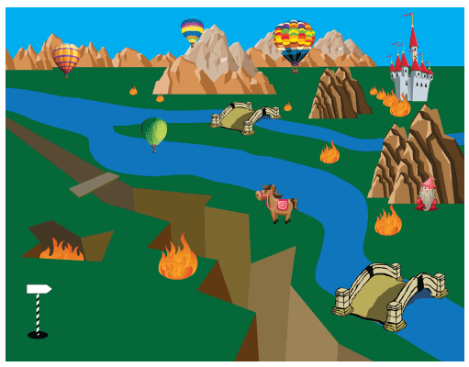

4. Add advantage spots.

#### 

5. Draw the path that will go through action spots

#### 

6. Draw step spaces along the path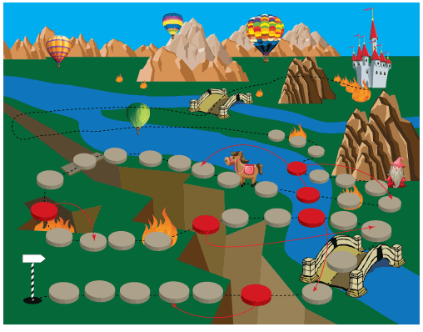

7. Mark return spaces. Use arrows or signs (ex.: return 3 spaces).

#### 

8. Mark advance spaces with arrows or signs.

#### 

9. Mark other actions (skip turn or skip 2 turns, etc)

#### step 4

Create the board & play pieces

#### step 5

Write down and design the game rules

Source : <https://juliannakunstler.com/vislit_boardgame.html>